Sumit Vadaviya

Camunda BPM Expert, Corporate Trainer

Email : sumit.vadaviya@trainosoft.com

I

n this session we will have quick overview of camunda tasklist web applications.

**Tasklist**

A ready-to-use web application that allows end users to work on the tasks assigned to them.

Camunda Tasklist help end users use to organize and work on BPMN user tasks they are supposed to complete.

During process execution, the camunda engine will create tasks based on the predefined BPMN model. The engine assigns those tasks to end users as defined in the model. When end users click on a task in Camunda Tasklist, they will see a task form that displays information and asks them to enter data. Once they have finished working on the task form, they complete it by clicking on a button prompting the Camunda Engine to continue the model execution.

Camunda Web Application Tasklist

Task list enable end user to

* Start a process
* Create a filter
* Claim tasks
* Working on tasks
* Set follow-up date
* Comment task
* Set due date

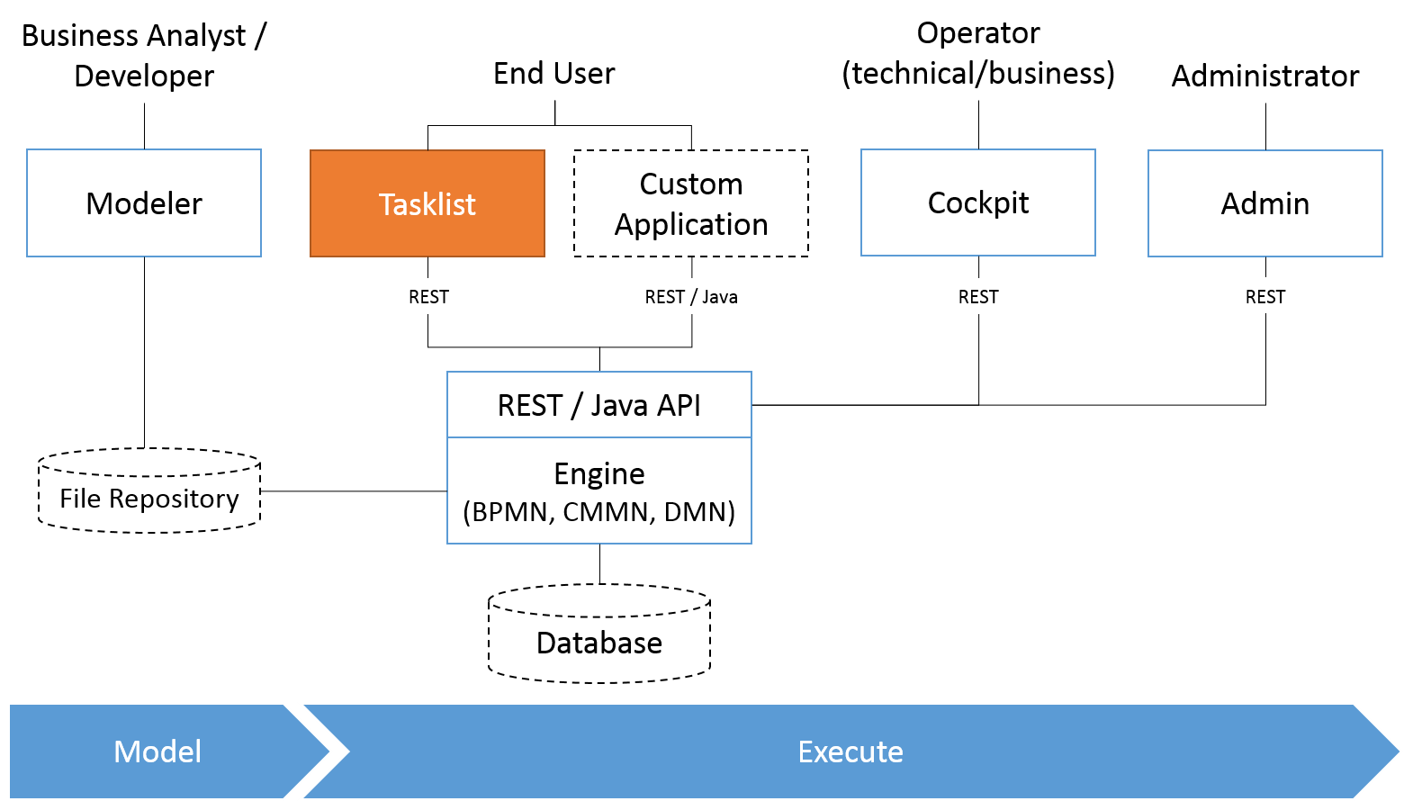

**Start a process**

To start a process instance via Tasklist, click on Start process in the header menu of the dashboard and select a process out of the displayed list of process definitions. After selecting the process to start, complete the start form. Hit Start to continue to the next step.

If no process definitions are listed here, please verify that your process application is deployed correctly or you have access rights to start the processes.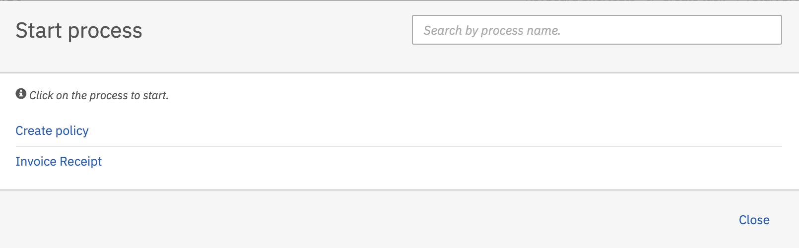

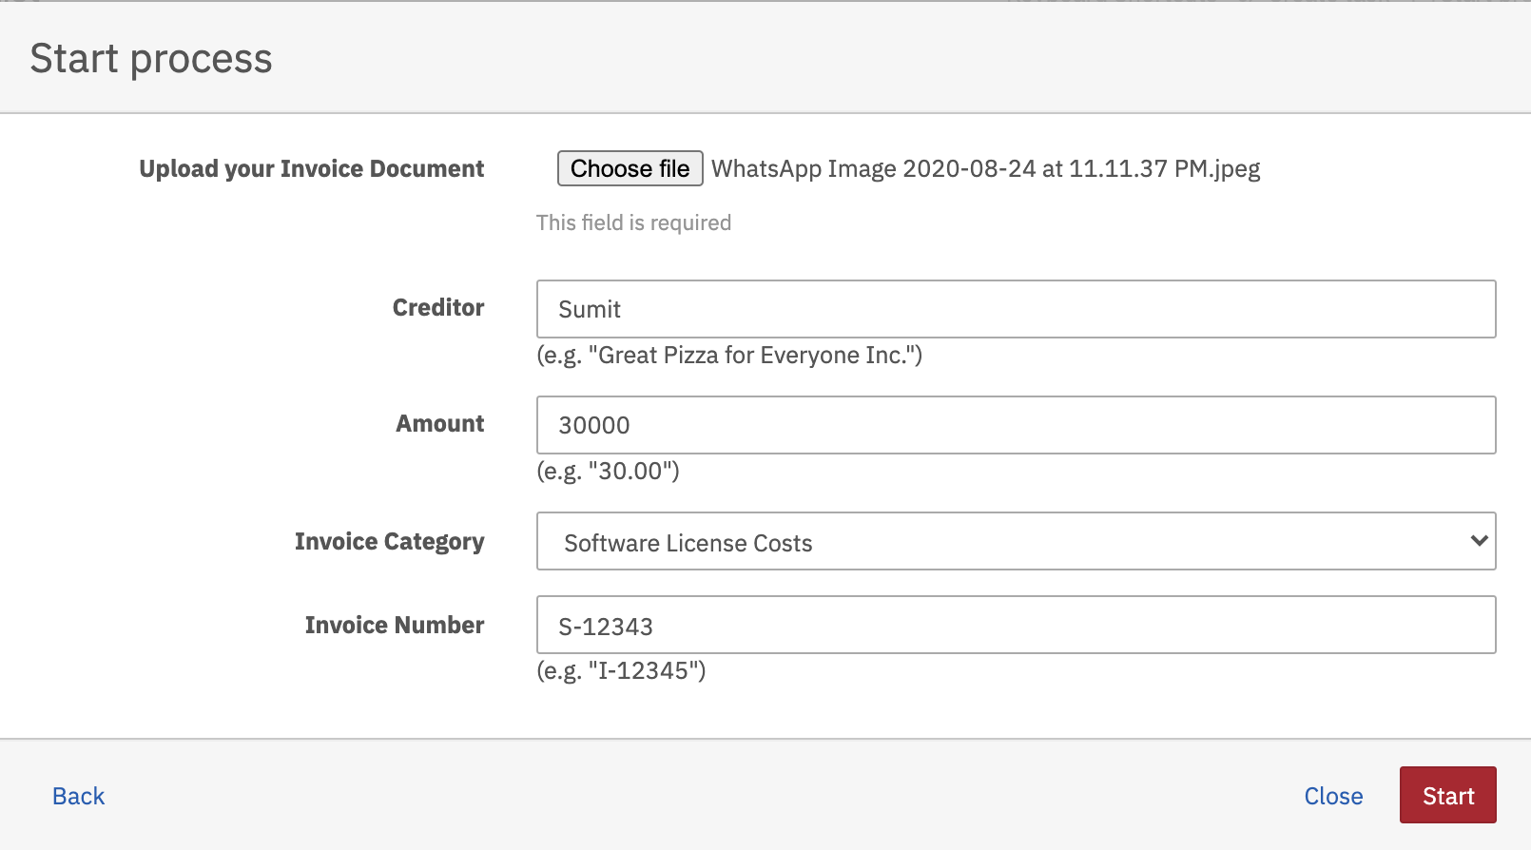

Select the process Invoice Receipt, fill up the process form and hit the Start button.

**Create a filter**

1. we will create a filter to display all tasks which belong to the process definition Invoice Receipt and task’s group is management. To do so, click on Create a Filter and insert a name for the filter, e.g., My invoice tasks.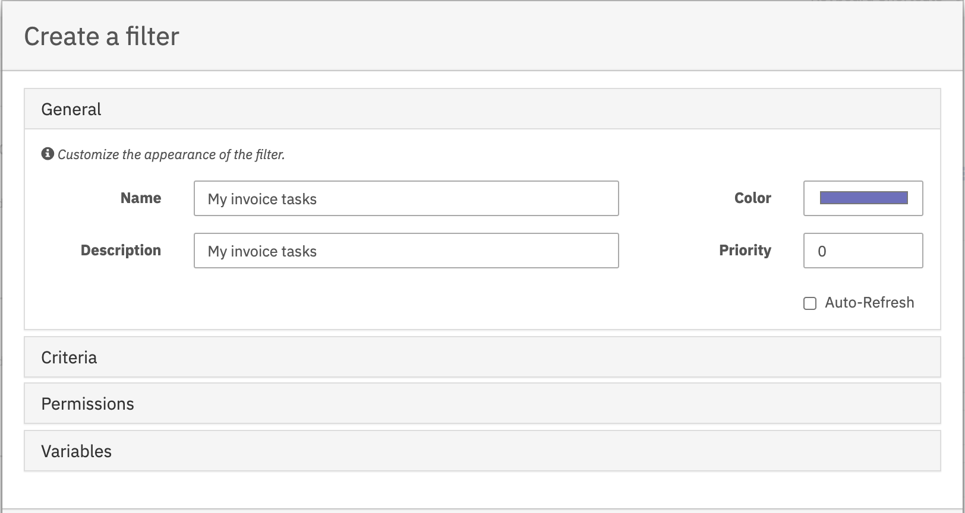

2. Then click on Criteria and on Add Criterion. Next, click on the empty Key field, select Name in the Process Definition submenu and insert Invoice Receipt into the Value field.

Click on Add Criterion again, select Candidate Group* in the User/Group submenu of the key field and insert management into the value field.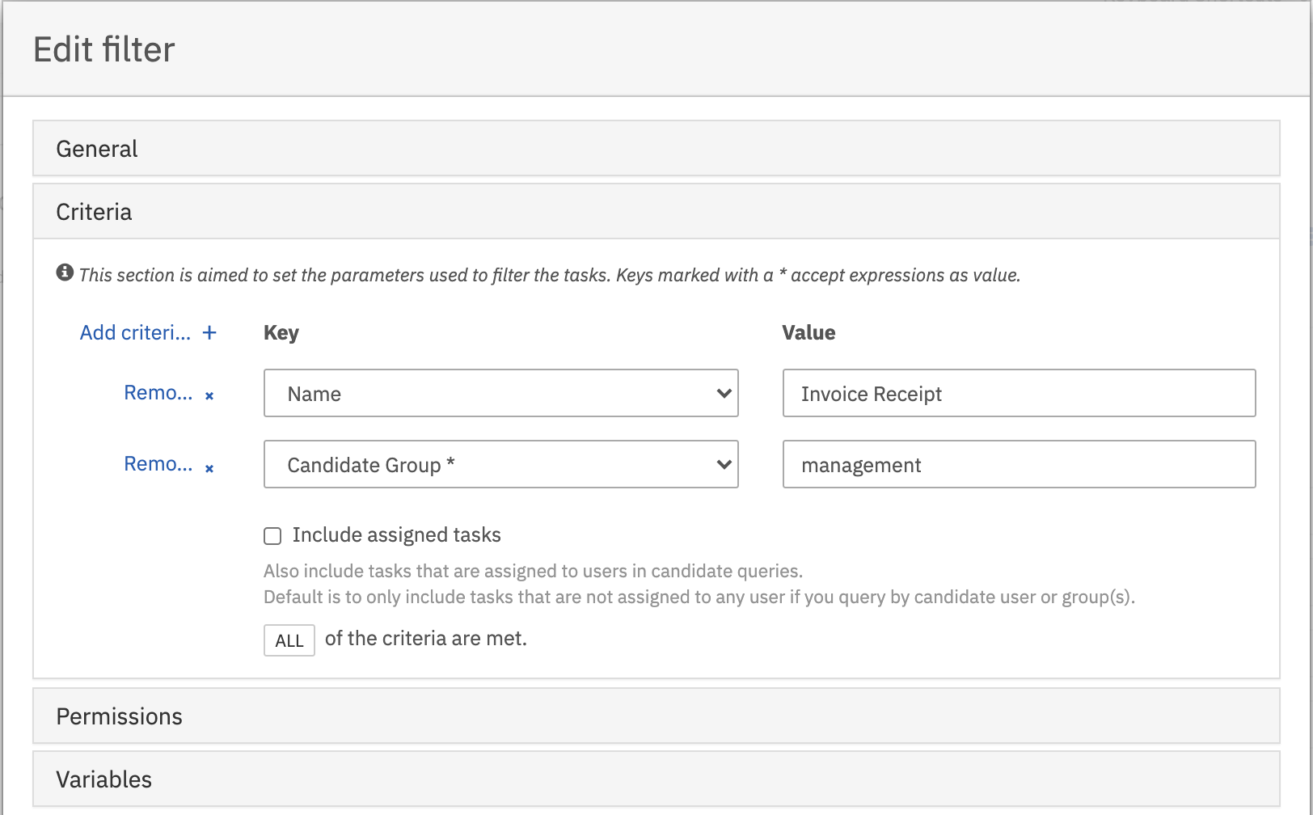

Now you can see the filter on the left side of the dashboard. Click on the filter to display the user tasks.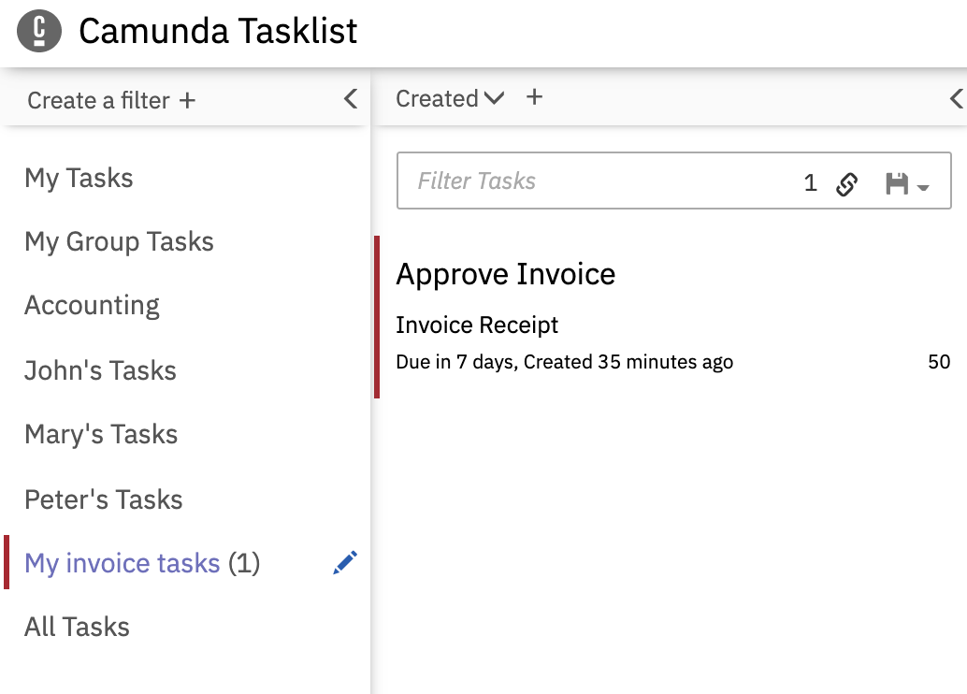

**Claim a task**

User can claim the task if task is assigned to the group which user is member of. In our case demo user is a member of management group so demo user can claim the task.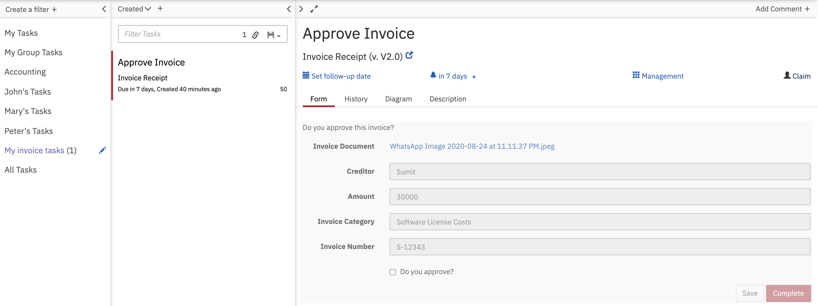

One demo user claim the task. Task will be assigned to him and he can complete the task now.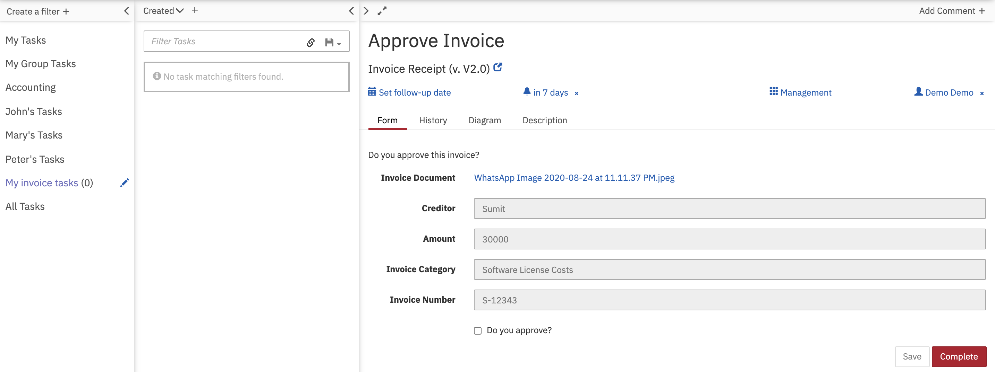

**Working on task**

User can start working on task by providing required inputs in order to complete the task. In our case user is asked to approve an invoice (or not). To complete the task, either tick the checkbox at Do you approve? or not and click on Complete button.

**Set follow up date**

we will set a follow-up date (reminder) for the task so that we don’t forget about it. To do so, click on Set follow-up date in the [task view section](https://docs.camunda.org/manual/7.7/webapps/tasklist/dashboard/#task-view) and select a date in the calendar that is displayed. We can also set an exact time for the follow-up.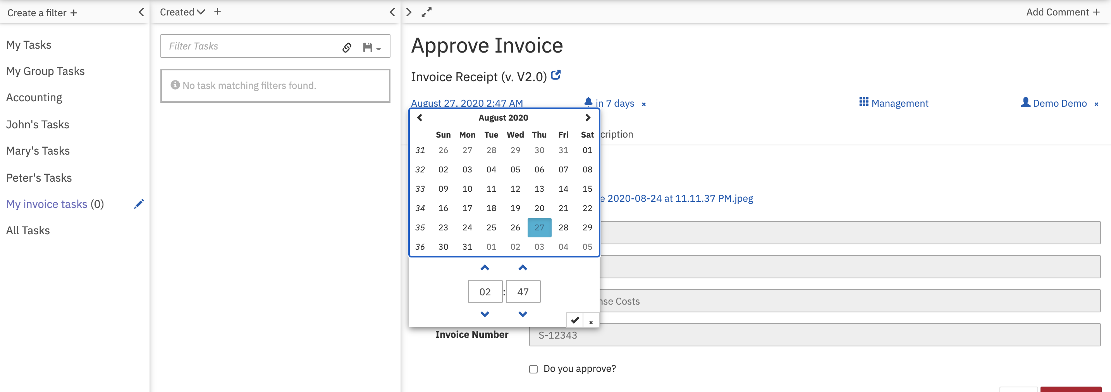

**Comment a task**

User can add a comment for other Tasklist users to see. To do so, click on Add Comment at the top of the task view section and insert the comment, e.g., “Hi Mary, please review this task”. The comment can now be seen in the task history.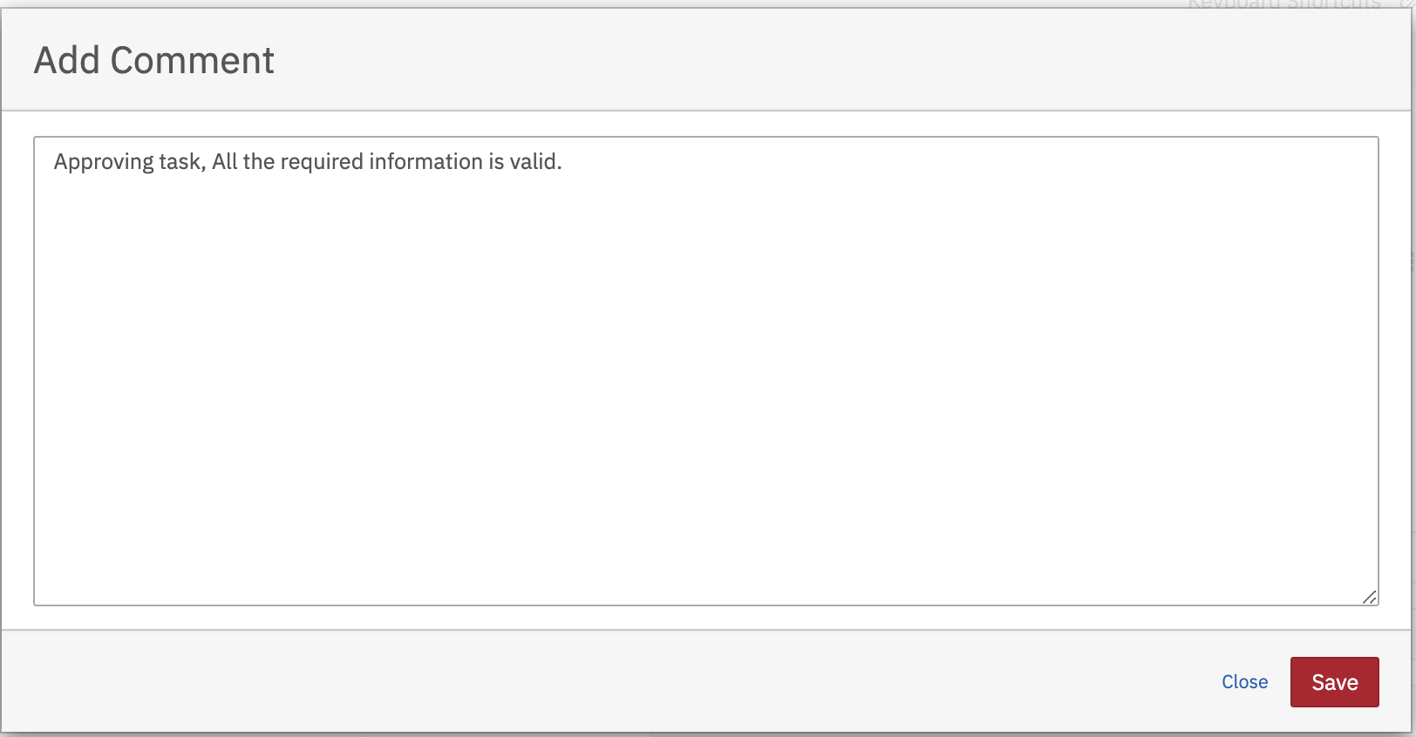

Added comments can be seen from history of the task.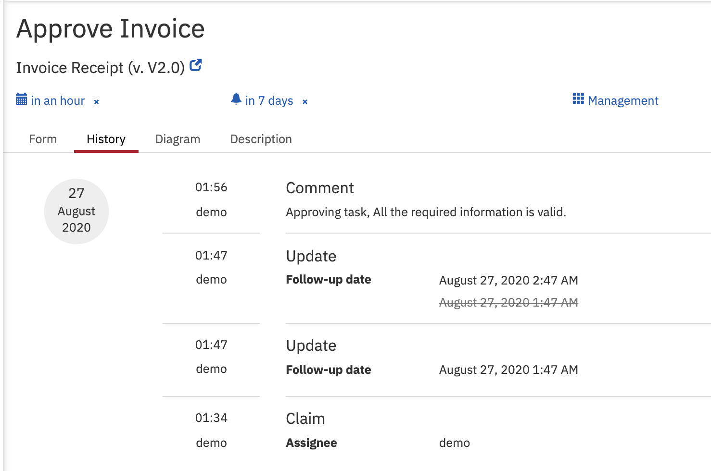

**Set a due date**

User can set a due date for task, to ensure that the task is handled on time. To do so, click on Set due date in the task view section and select a date in the calendar that is displayed. You can also set an exact time.

**Create a standalone task**

User can create standalone tasks. To do so, click on the Create task button. In the screen that appears, you can define a name of the task, the assignee and you can add a description. Once you click on Save, the task is created.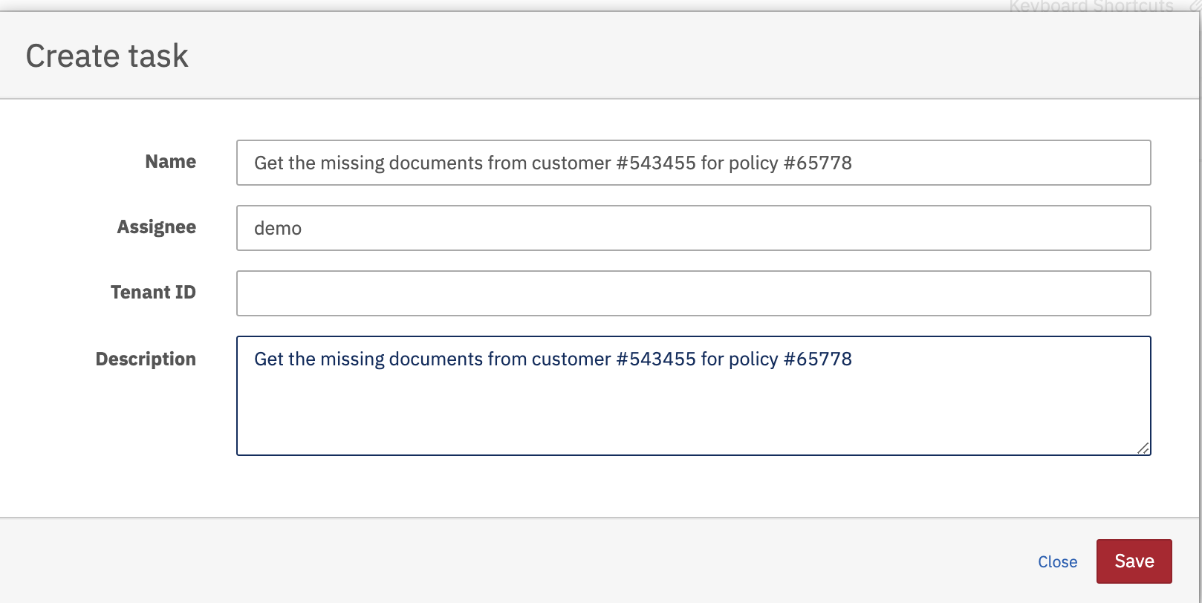

Standalone task will be visible in the filter results and can be handled. Variables can be added and the Task can be completed. Once the task has been completed, the data is flushed to the database and the task is no longer visible in Tasklist.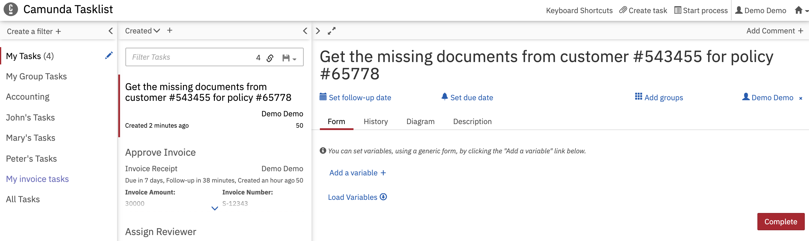

**Sorting task list.**

Tasks can be sorted out by various fields as per below screen.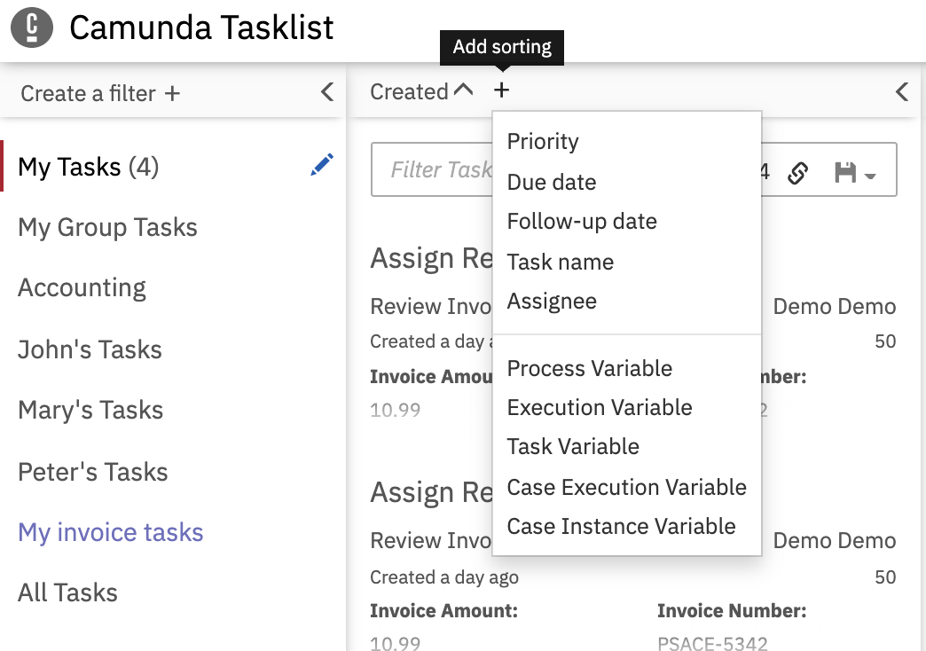

**Add filter to task list**

You task filter the task by various criteria. You can see tasks have been filtered out by due date after August 27, 2020 2:47 AM.